ASSIGNMENT 2 K.Bhanuteja

**DAY-5**

**1. Develop a system using UML for Home Services System. HACS is a system controlled by a remote system such as a mobile phone and coordinates home appliances. The document furnishes the detailed design with all the UML diagrams. It encompasses CRC cards, Use Case Diagrams, Sequence Diagrams, and Class Diagrams for home appliance control systems (HACS).**

**AIM:-**

To develop a system using UML for Home Services System.

UML DESIGNS:-

1.USE CASE:

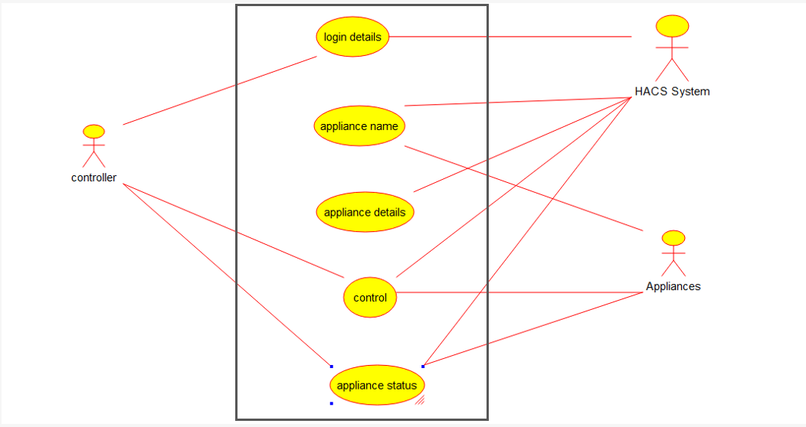

Activity diagram

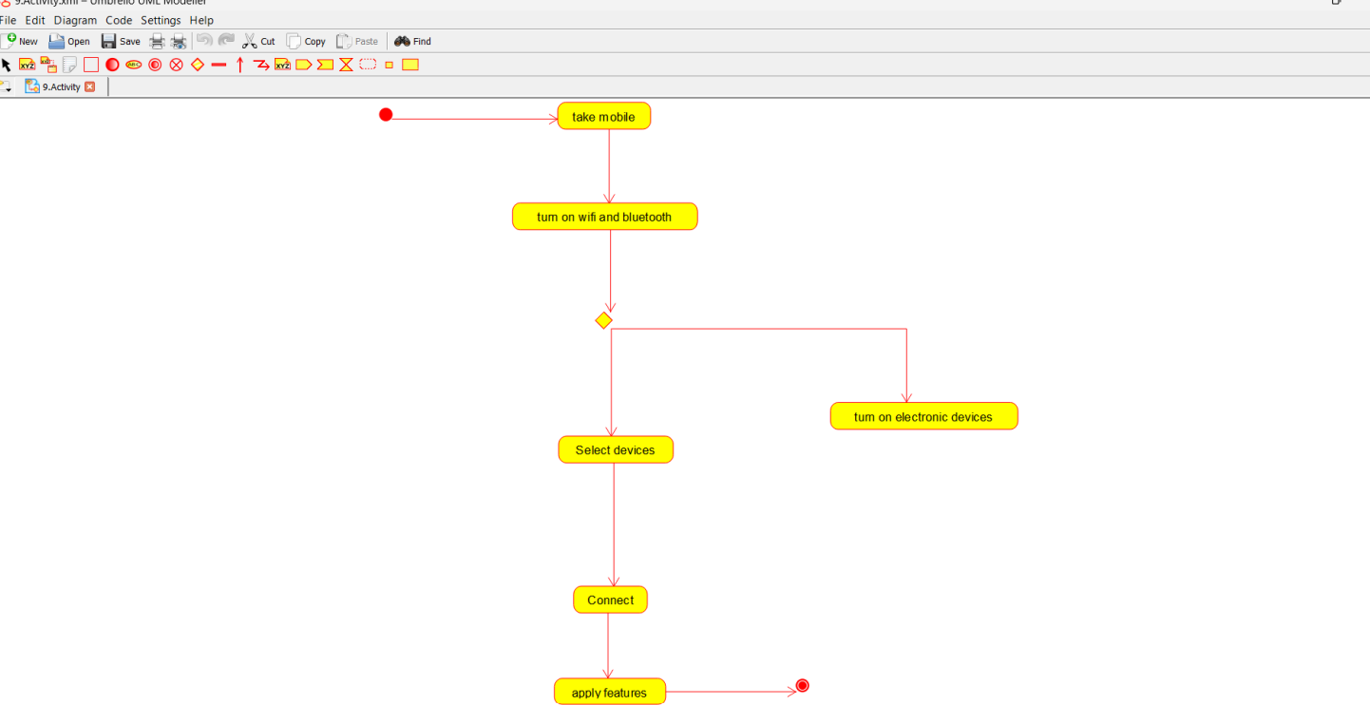

2.CLASS DIAGRAM:

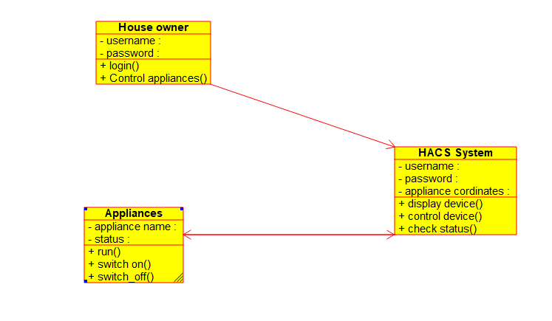

3.SEQUENCE DIAGRAM:

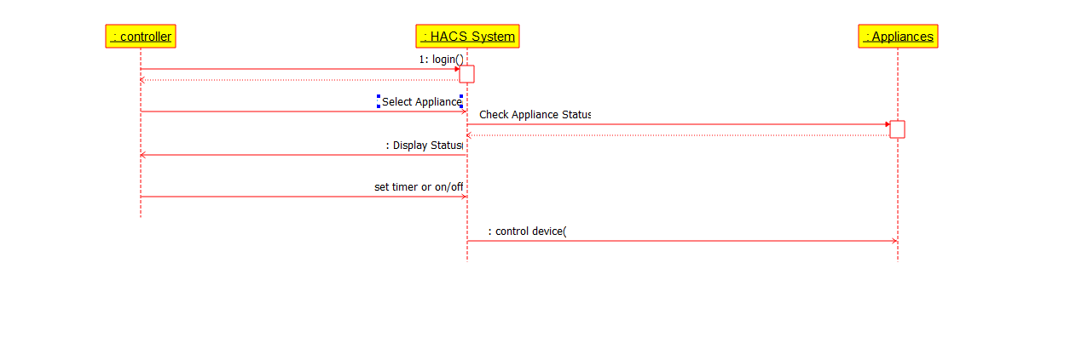

**2. Develop a system using UML for Online Insurance Processing System. The admin can create a category and sub-category, under which a new policy can be added. The user can view and buy the required policies. The system is managed by the Insurance Management System.**

**AIM:-**

To develop a system using UML for Online Insurance Processing System.

UML DESIGNS:-

1.CLASS DIAGRAM:

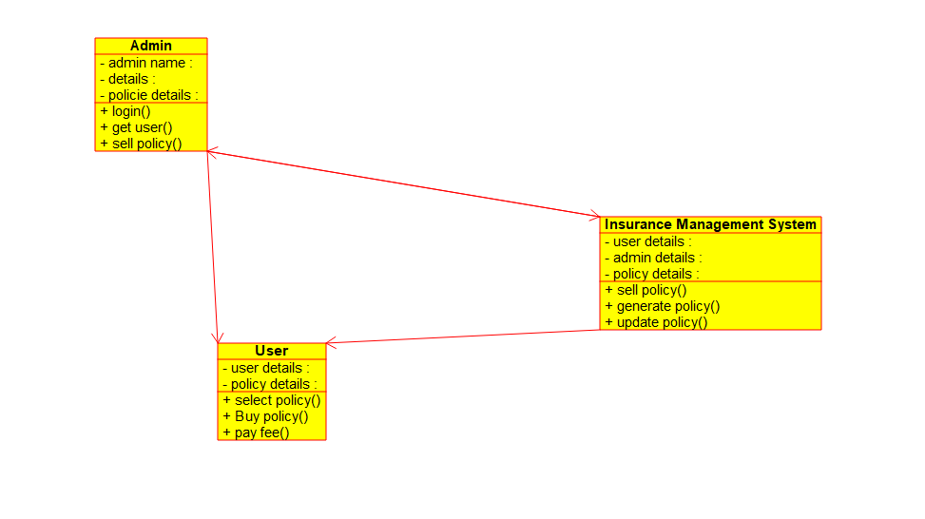

2.DEPLOYMENT:

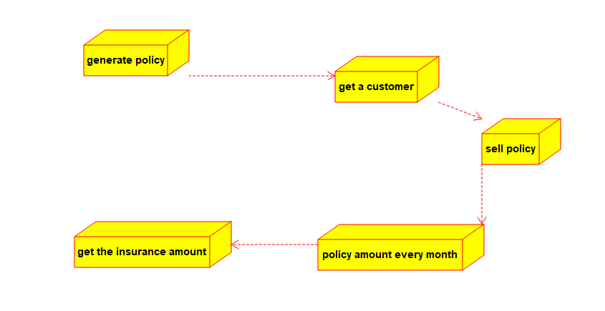

3.ACTIVITY DIAGRAM:

